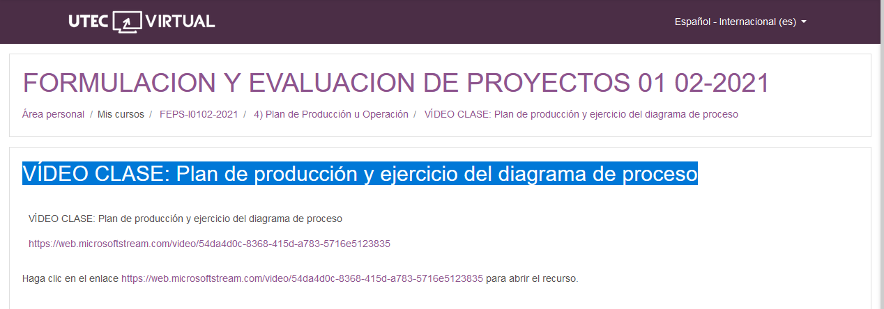

<https://web.microsoftstream.com/video/54da4d0c-8368-415d-a783-5716e5123835>